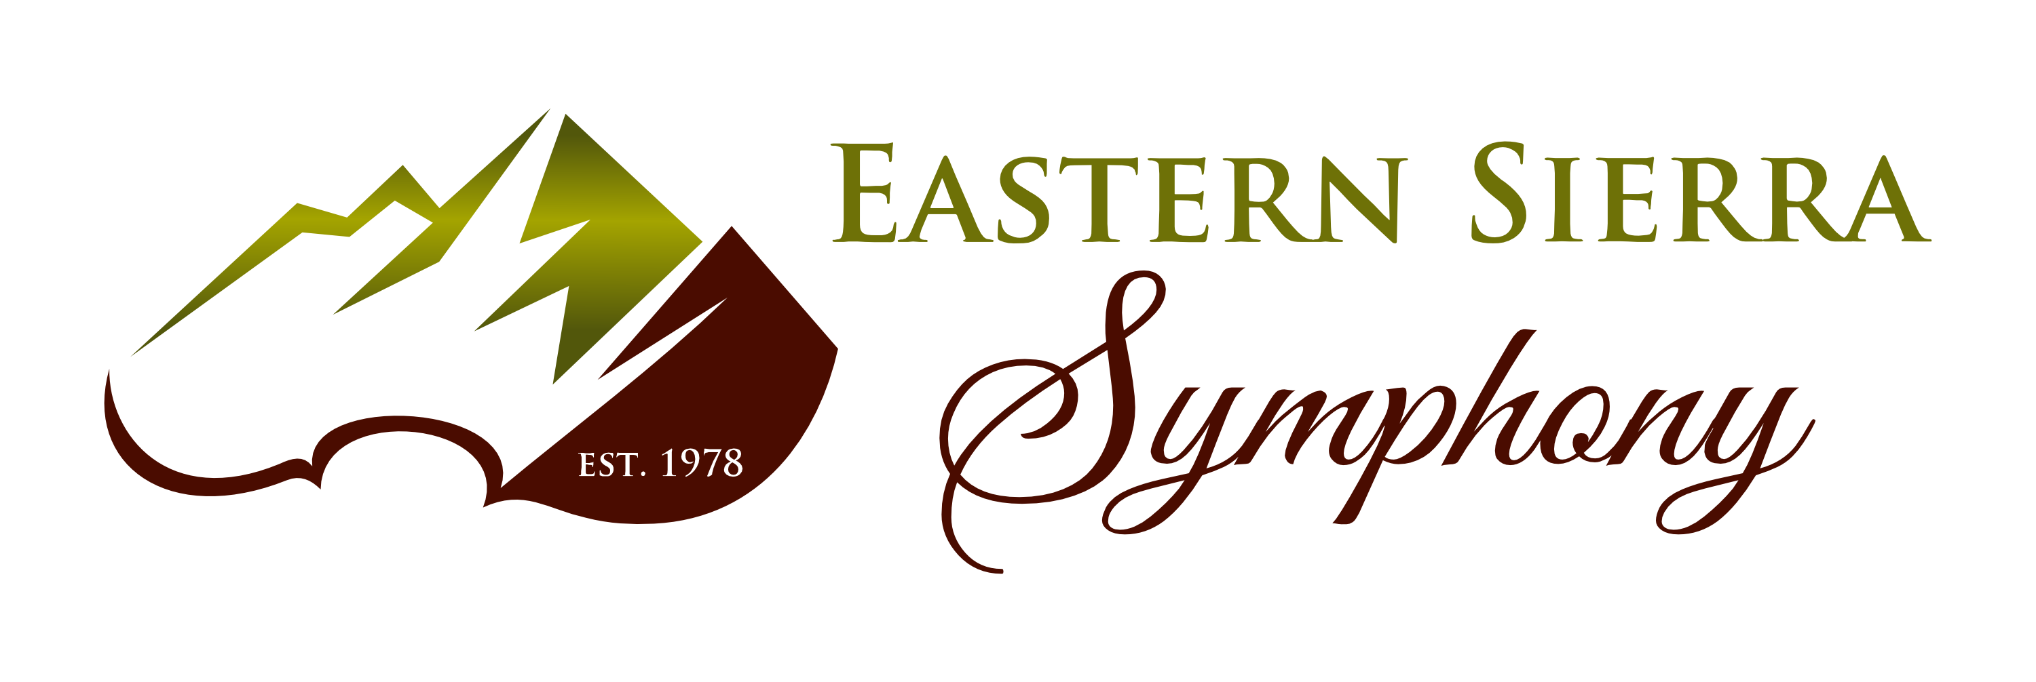

* **CARING CONTRIBUTOR ($50-$99)**

Your name appears in the season program.

* **FESTIVAL FRIEND ($100-$249**

Your name appears in the season program.

* **SYMPHONY SUPPORTER ($250-$499)**

Your name appears in the season program.

* **CONDUCTOR'S CIRCLE ($500-$999)**

You receive one ticket to the Saturday concert and your name appears in the season program.

* **GRAND PATRON ($1,000-$1,999)**

You receive two tickets to the Saturday concert and your name appears in the season program

* **CORNICE CLUB ($2,000-$4,999)**

You receive four tickets to the Saturday Concert. Your name appears in the season program.

* **MAJOR BENEFACTOR ($5,000-$14,999)**

You receive six tickets in the Reserved Section of the Saturday Concert, your name appears in and you receive placement of a half page ad in the season program.

* **SHINING STAR ($15,000 AND UP)**

You receive eight tickets in the Reserved Section of the Saturday Concert, listing as the main sponsor of one of the summer 2016 concerts (Friday or Saturday) and you receive placement of a full page ad in the season program.

**DONOR LEVELS**

**Eastern Sierra Symphony**

(formerly Sierra Summer Festival)

is a 501(c)(3) nonprofit corporation.

Your donation may be tax deductible.

**Make your checks payable to:**

**Eastern Sierra Symphony**

**Mail to: P.O. Box 7710**

**Mammoth Lakes, CA 93546**

***Thank you!***

**NAME__________________________________________________________**

**ADDRESS_______________________________________________________**

**CITY/ST/ZIP____________________________________________________**

**PHONE_________________________EMAIL__________________________**

**AMOUNT OF DONATION_________________**

**CC#___________________________________ CCV: ______ Exp.Date_____re**

🗖 Check here only if you want your name excluded from mailings.

Ticket sales alone do not cover the considerable costs of producing a music festival. We are most grateful for your tax-deductible contribution so we may continue to attract high-caliber musicians and bring outstanding music performances to the Eastern Sierra.